ASSIGNMENT-2/ Day 6

Question 1

1. Create Payload for Windows

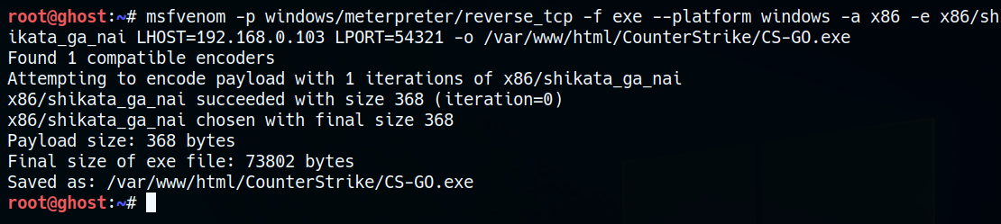

1. Transfer the Payload to the Victim Machine

1. Exploit the Victim Machine

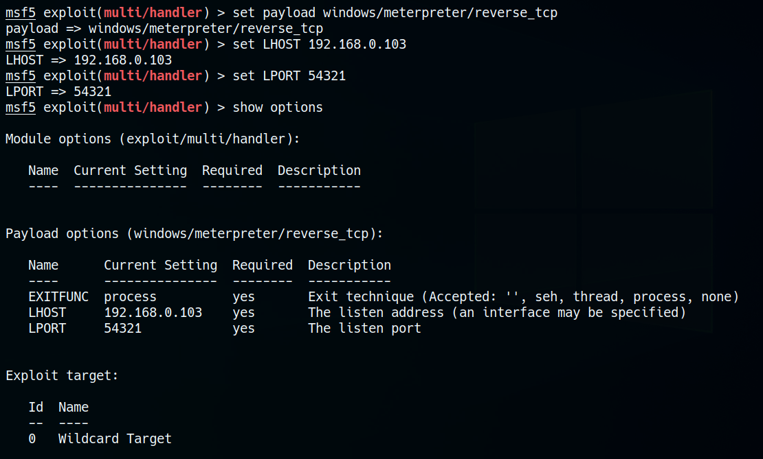

Now anything can be done in the victim machine

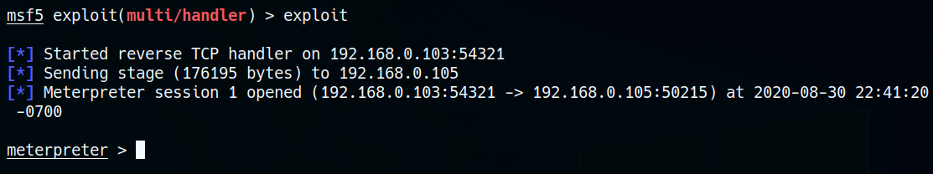

Question 2

1. Create an FTP Server

Now we will check for the open ports of FTP

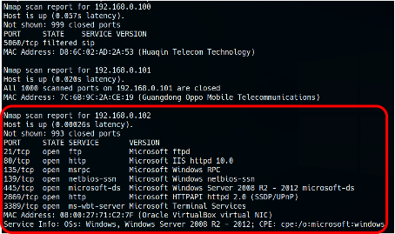

1. Access FTP Server from Windows command prompt

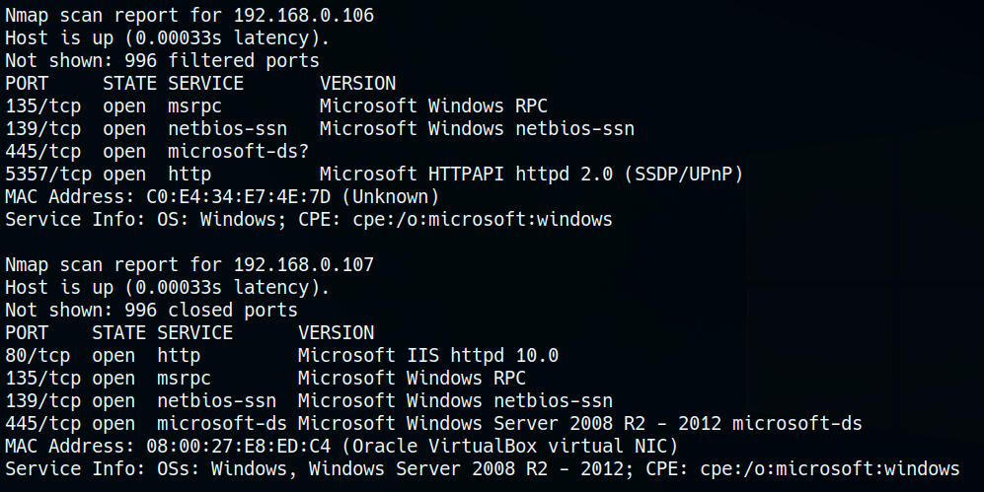

1. Trying ARP spoofing

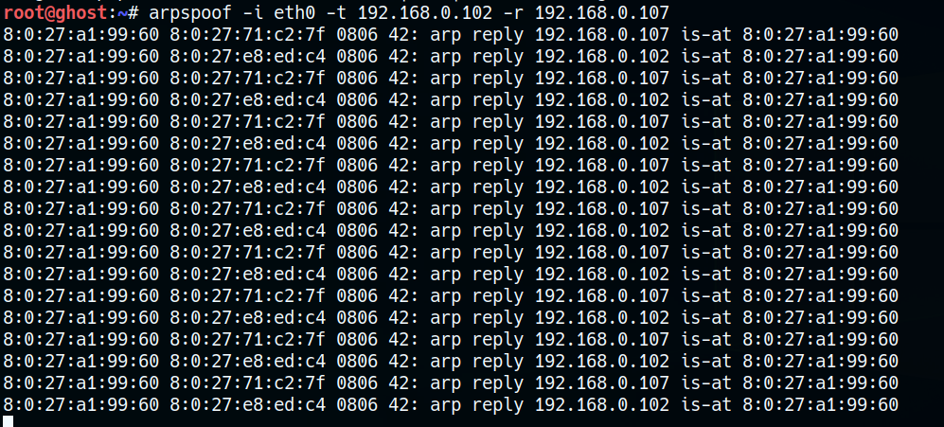

1. Trying to attack using dsniff and getting the username and password

